SD03 CSS & CSS Frameworks | Responsive Layout & Flexbox

From Mockups to Code

Activity: Pillow Talk Mockup

A big and normal struggle when it comes to HTML/CSS is taking a mockup and turning it into a real website. As with most things, it just takes practice. Let's practice one together.

Setup

Instructions:

1. Click [HERE](https://github.com/HackerUSA-CE/CSS-Pillow-Talk-Mockup) for the link to the repo.
2. Fork (not clone) it to your **OWN** GitHub account.
3. Now to clone the repo to your machine, click the green 'Code' button and then copy the URL.
4. In a new terminal, or Git Bash, go to where you want to clone the repo.
5. Type git clone in the terminal or Git Bash, then a space, then paste the URL you copied from your repo. **Example:**

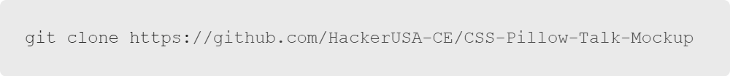Click here to copy

1. Hit "Enter" or "Return", whichever is on your keyboard.
2. Now, in your terminal, change to your repository directory (cd repo name)
3. Open your repository in Visual Studio Code.
4. Open terminal in your Visual Studio Code.
5. Do the assignment in Visual Studio Code and stage your changes using the git add -A command.
6. Make at least one commit by using the git commit -m "write your message here" command. **Example:**

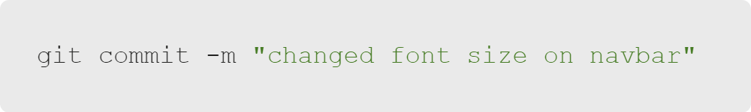Click here to copy

1. Finally, push your changes using the git push command.**Example:**

Click here to copy

1. Open the index.html in your browser so we can check our code along the way.

Pillow Talk

We saw it on the slides, but let's take a closer look at our mockup and the breakdown of all the elements.

**The mockup**

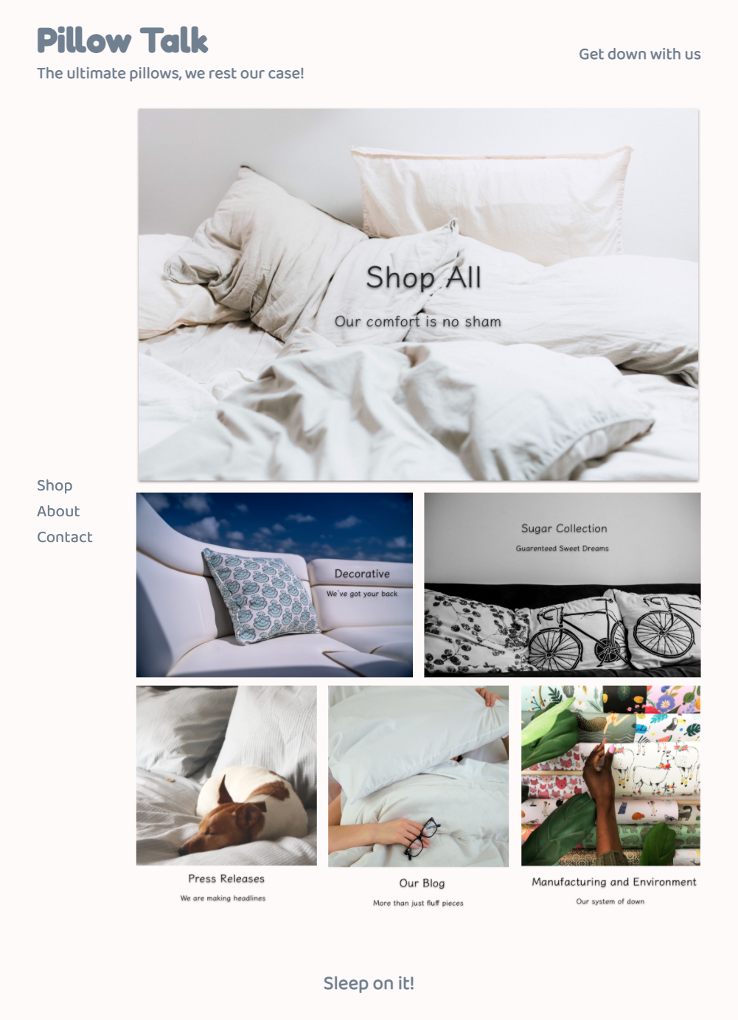

**Breaking down the components and the elements they're made of**

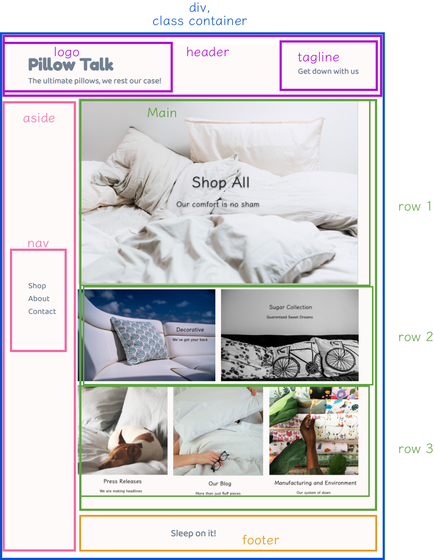

Note: This site was inspired by a real site at hullopillow.com

Getting Started

With every HTML/CSS build we start, what are the first things we should do?

* HTML boilerplate
* Link the CSS file to HTML file

Once you're done with those initial steps, let's add some CSS helpers and basic styling.

**styles.css**

Click here to copy

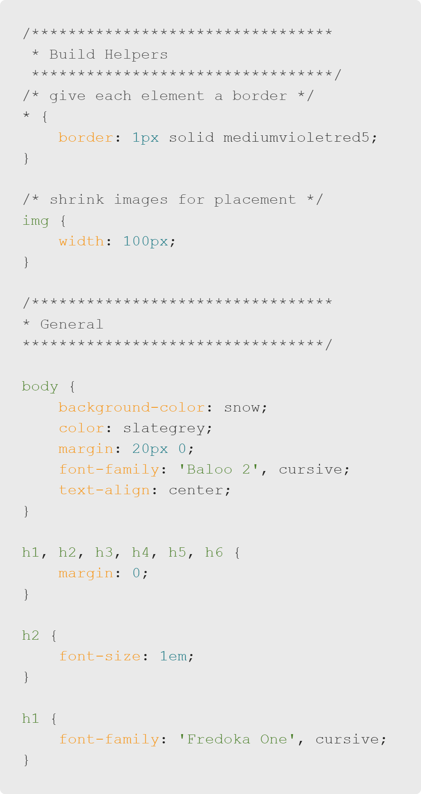Click here to copy

Adding HTML Containers

Now that we have some basic styling going, let's put some basic things down on the HTML. Earlier, we already sketched out what elements we need. Let's put down some of the containers we sketched out, in the following order.

* header
* div with a class of container. This div should contain all the following:

aside

main

footer

**index.html**

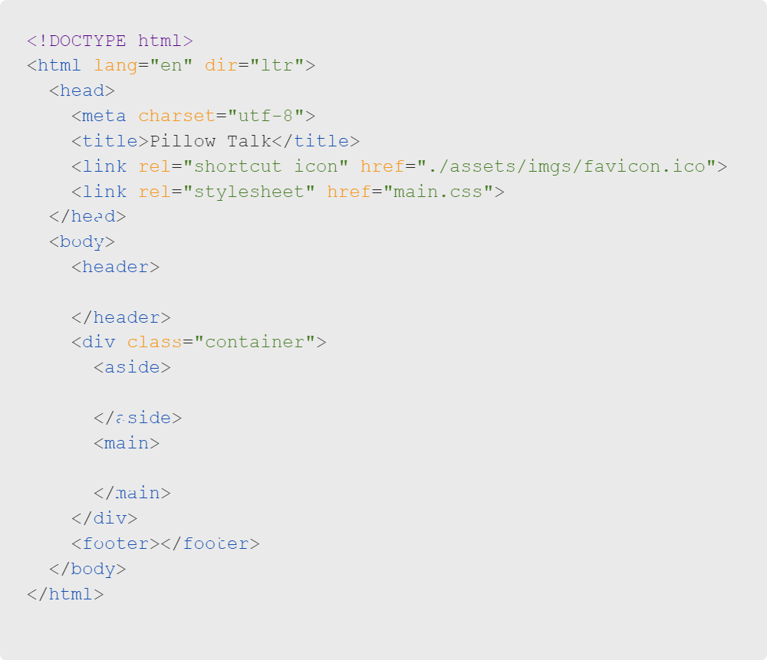Click here to copy

The Header HTML

Let's start adding some content into our HTML based on the given mockup, starting with the header.

**index.html**

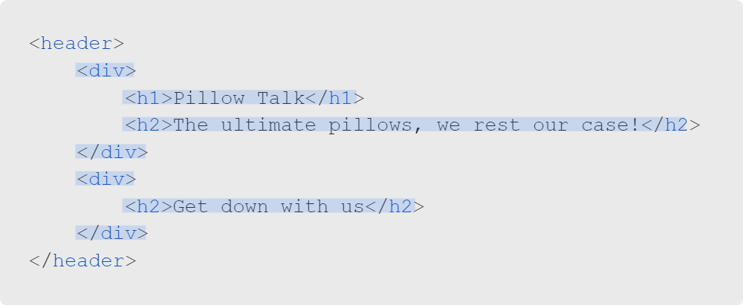Click here to copy

**What your browser should look like**

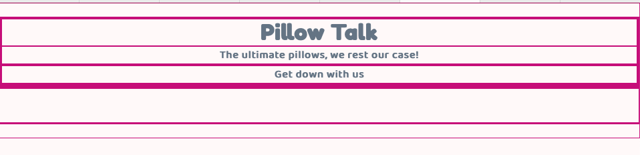

The Aside HTML

Now let's add the content for the aside.

**index.html**

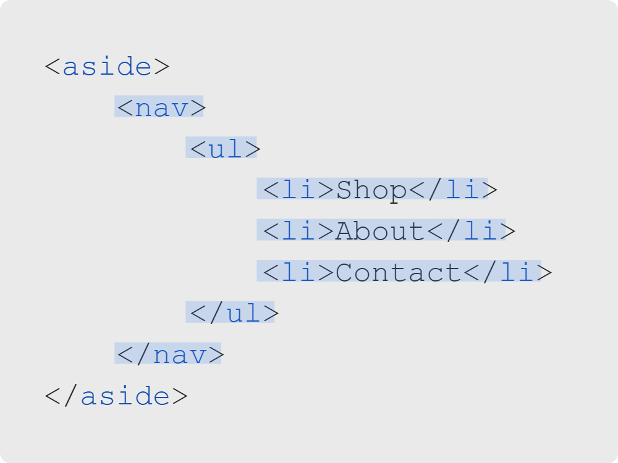Click here to copy

**What your browser should look like**

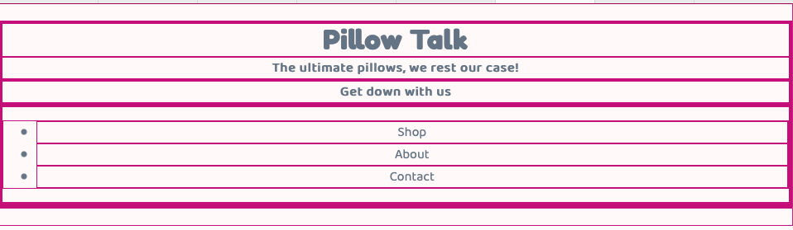

The Footer HTML

Now let's add the content for the footer.

**index.html**

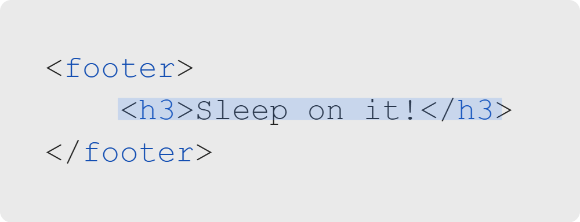Click here to copy

**What your browser should look like**

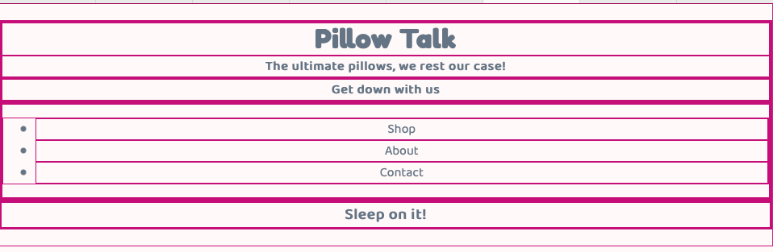

The Main HTML

The main section of the side understandable has a lot more components. Let's go through it step by step.

First, let's make three "rows" with div elements and give them all different row class names.

**index.html**

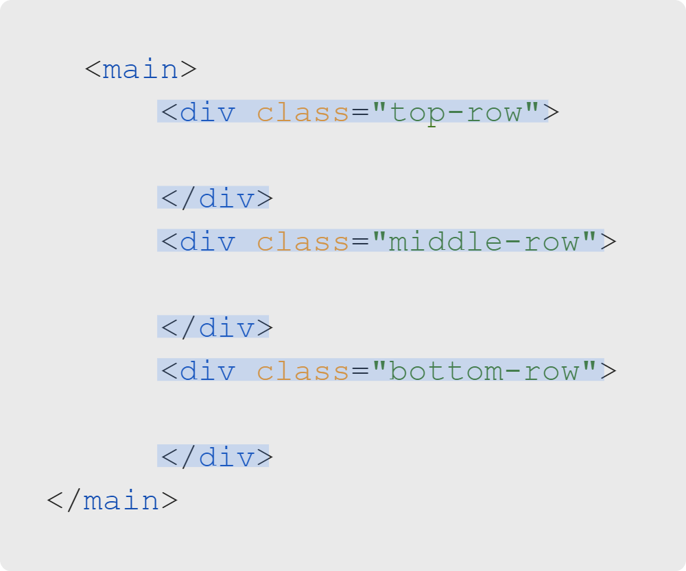Click here to copy

Remember, these divs have a height and width of 0 when there is nothing inside of them. So if we checked the browswer right now, all we would see are just more top/bottom borders.

Let's fill these divs with some images. The images are already provided to you in the repo, so we just have to relatively path to them.

**index.html: top-row**

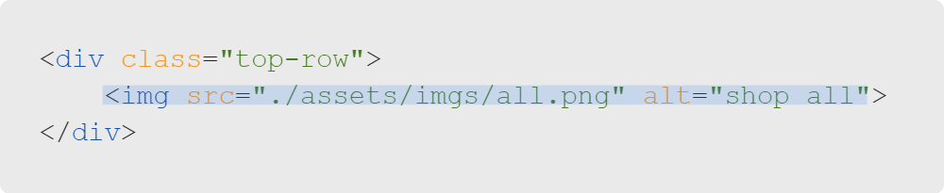Click here to copy

**index.html: middle-row**

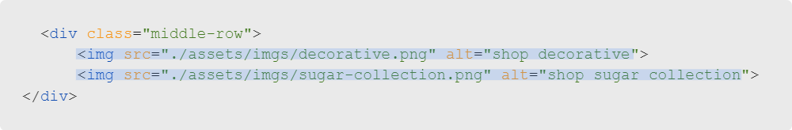Click here to copy

**index.html: bottom-row**

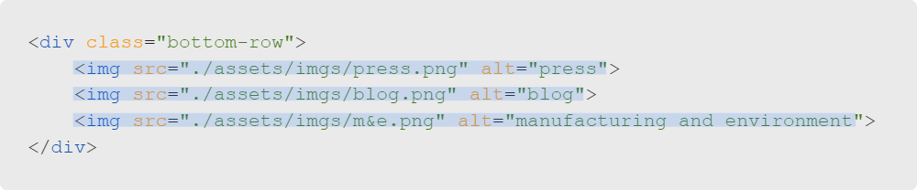Click here to copy

**What your browser should look like**

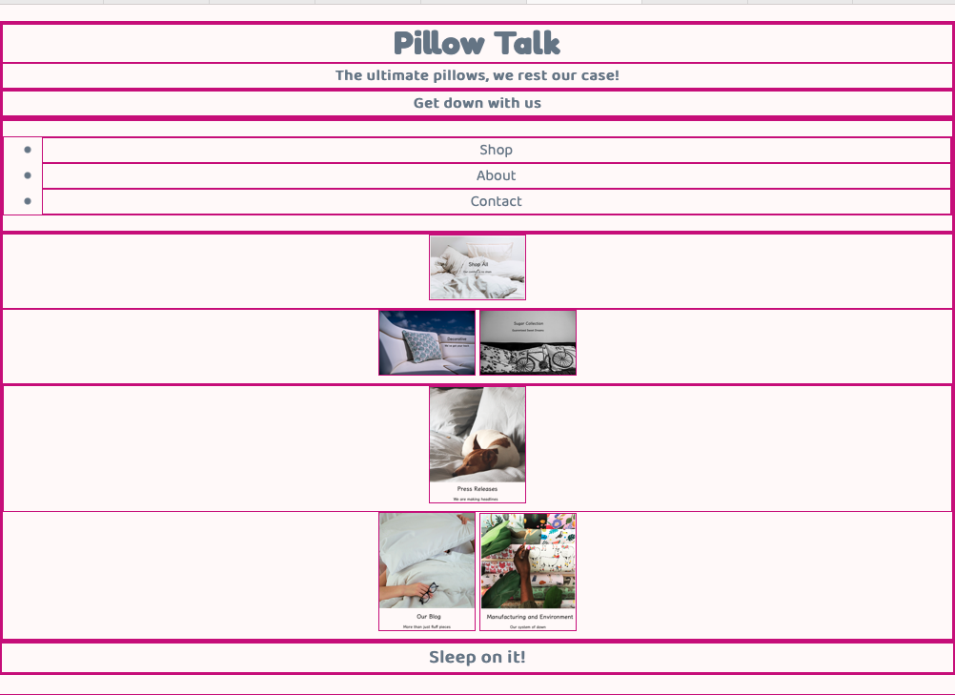

Nice! We've now completed our HTML. All that's left is to style it all with CSS.

CSS Organization

When coding in general, it's always a good practice to organize your code for better readability and navigation. Not only for others who might see your code, but for yourself as well. You might know where everything is and what everything does now, but in the future you might not.

So let's start building good habits and think about how to organize our code from the beginning.

In addition to the build helpers and general sections we already added before, we can further break our project down into:

* Header
* Container
* Aside/nav
* Main
* Footer

To organize, let's add these as headers in our CSS.

**styles.css**

Add these header comments below the general styles we added earlier.

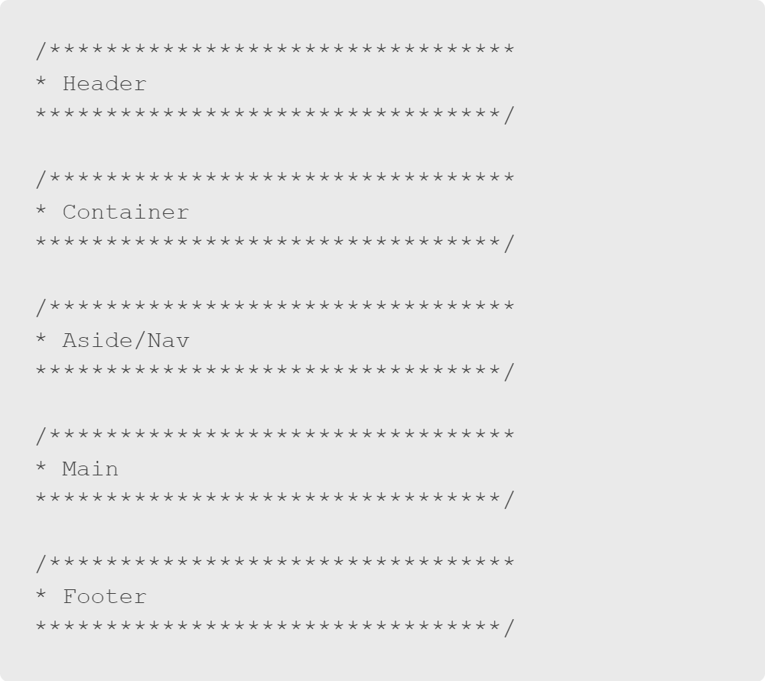Click here to copy

The Header CSS

Now that our code has some nice organization going, let's add some styling to try and match the mockup. Make sure all of the code below is put under the header section we just created!

**styles.css**

Styling for the header container

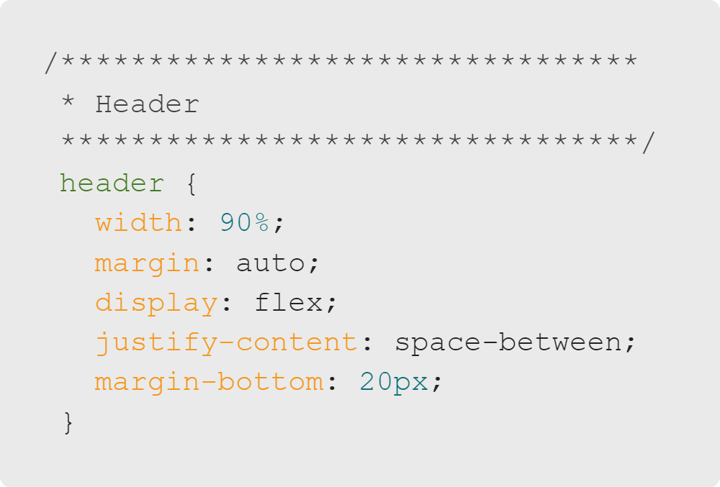Click here to copy

Styling for the div elements within the header

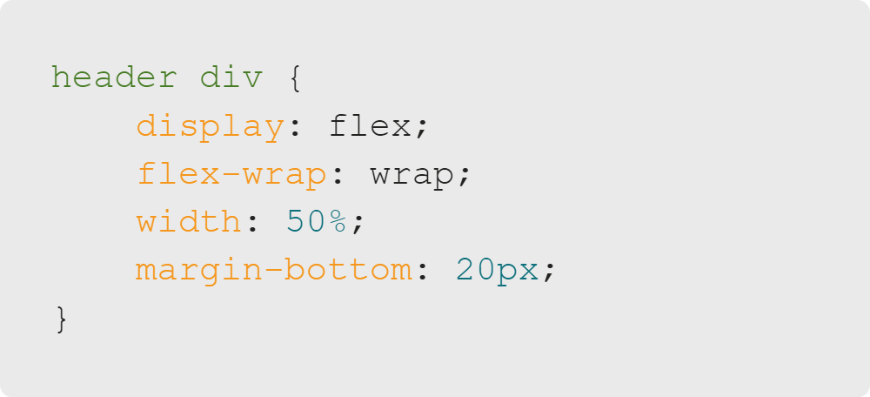Click here to copy

Styling for the h1 elements within the header

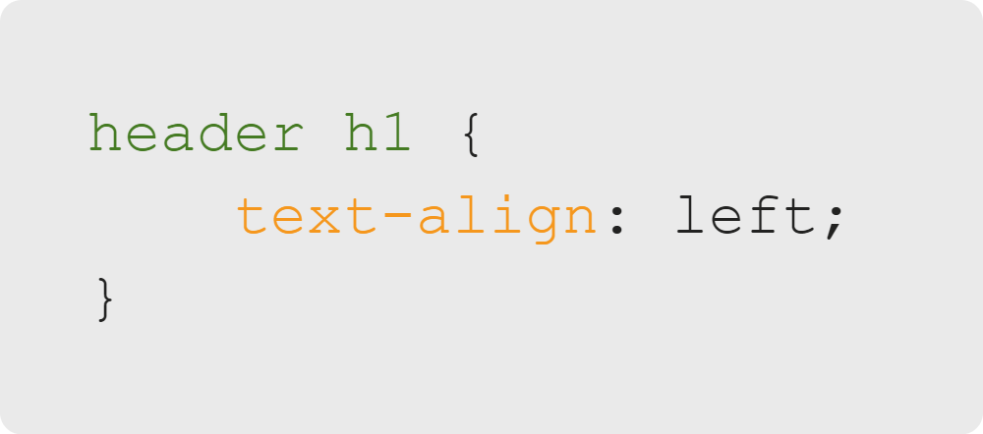Click here to copy

Styling for only the last div element within the header

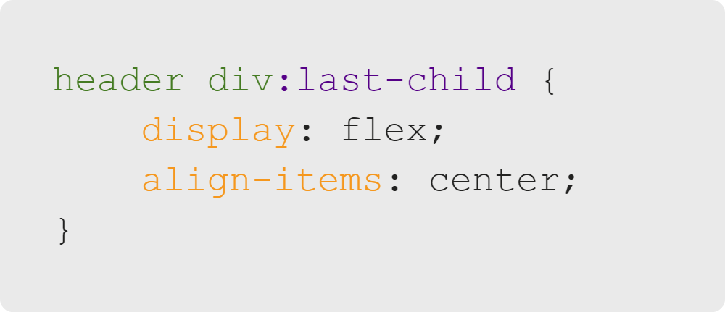Click here to copy

**What your browser should look like**

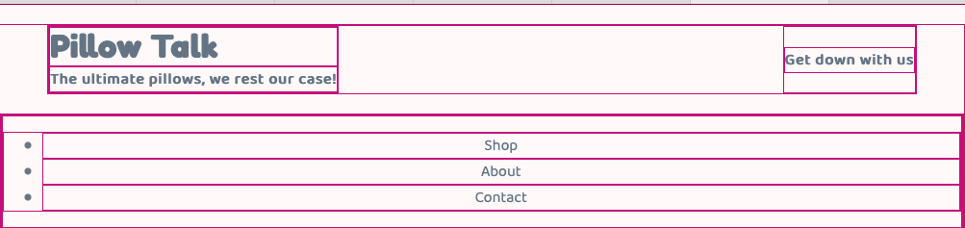

The Container CSS

Now that our header's all done, let's continue onto the main container that holds the main and aside elements. Our goal here is to make those two elements be side by side as opposed to in a singular column. We can use flexbox for that.

**styles.css**

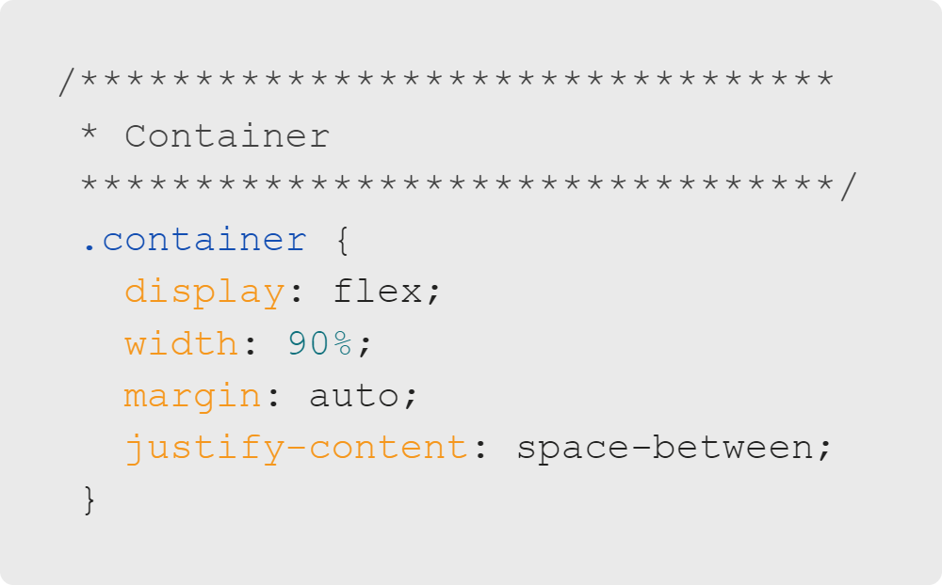Click here to copy

**What your browser should look like**

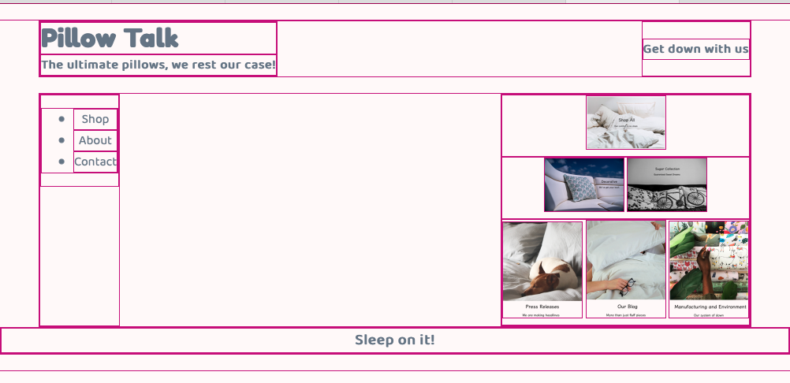

The Aside/Nav CSS

With that all set, we can now work on styling the inside of the container starting with the aside, which acts as a sidebar navigation.

**styles.css**

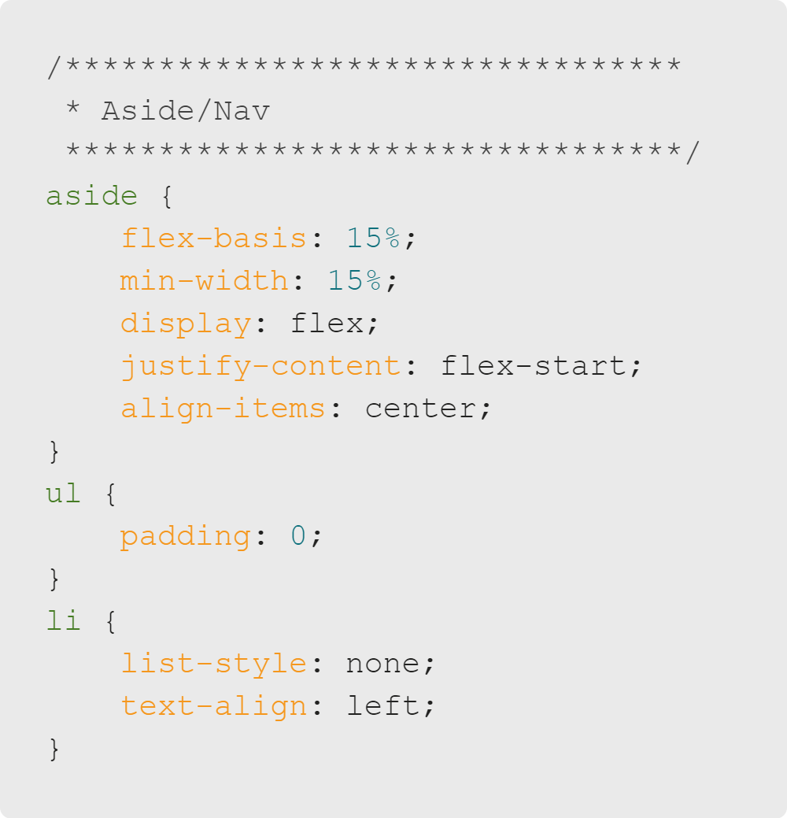Click here to copy

The Main CSS

Our main content looks a little weird. It's too close to the aside and doesn't take up the rest of the space like we want it to. Let's specify a width that it should take up.

**styles.css**

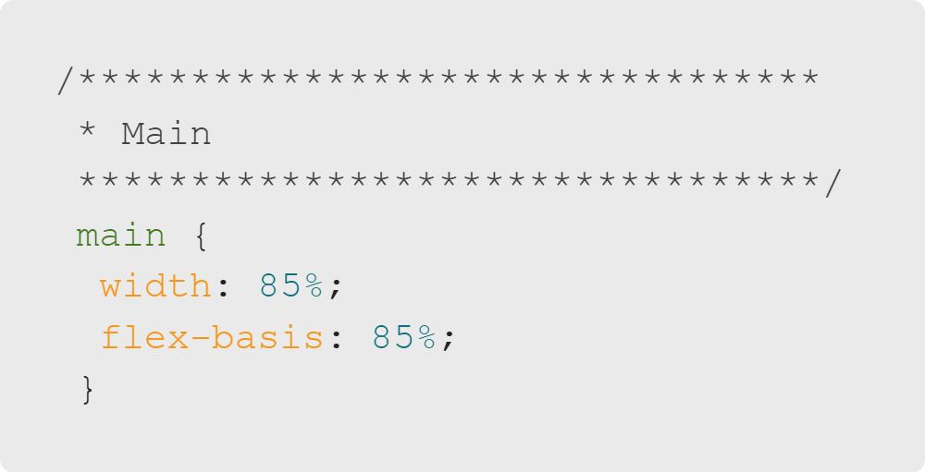Click here to copy

Okay, that's a little better. However, the images are still small and they're all in one long column. Let's fix that.

First, we want to select all rows and make them a flex container. Then, we can select each individual row's images and give them width percentages according to how many images there are in that row.

For example, there are 2 images in the middle row. So if we want them both to take up half of the row we should set their widths to 49%. We want to do 49% as opposed to 50% so that there is some space between the images.

**styles.css**

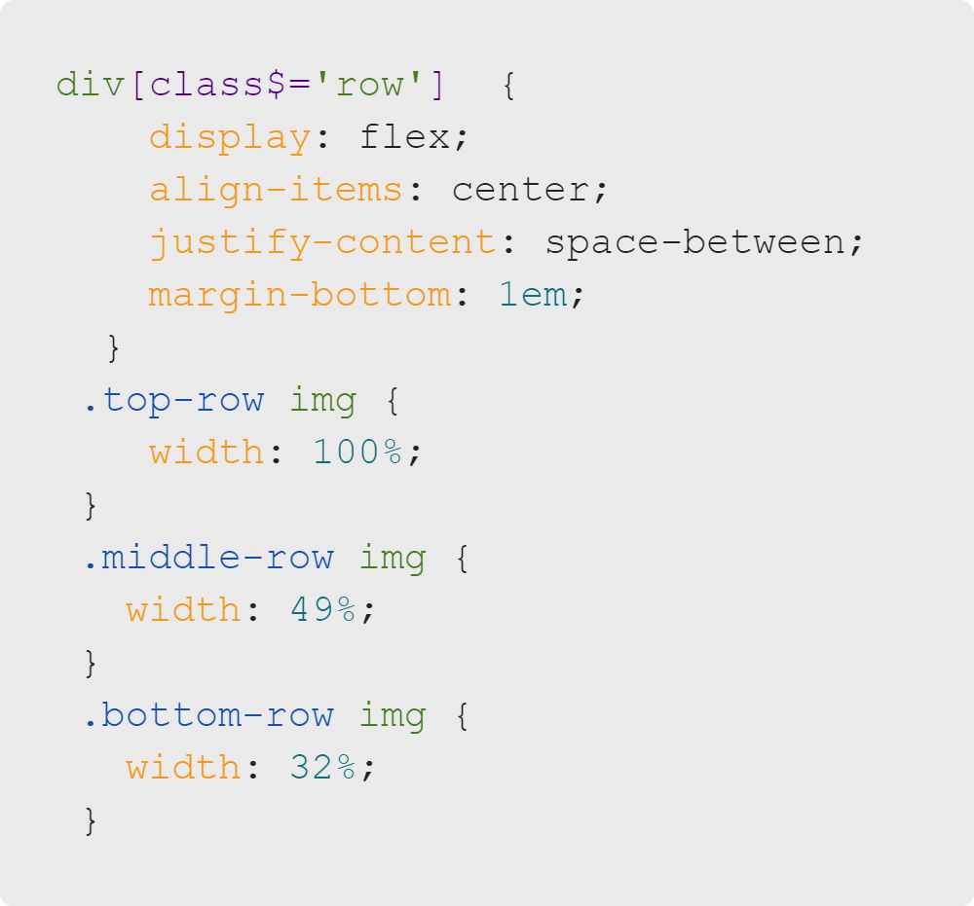Click here to copy

With that, we're done! All that's left to do is comment out the helper CSS we wrote at the top of the file to get rid of the borders.

Note: We created a footer comment header earlier, but it turns out we don't need to add any additional styling to it! Feel free to delete the comment header if you wish.